**Pivot Table Project**

There are seven columns and 714 rows in our dataset. This represents sales data for a company from 2019 to 2022. The “Amount” column refers to the sales amount for the particular date.

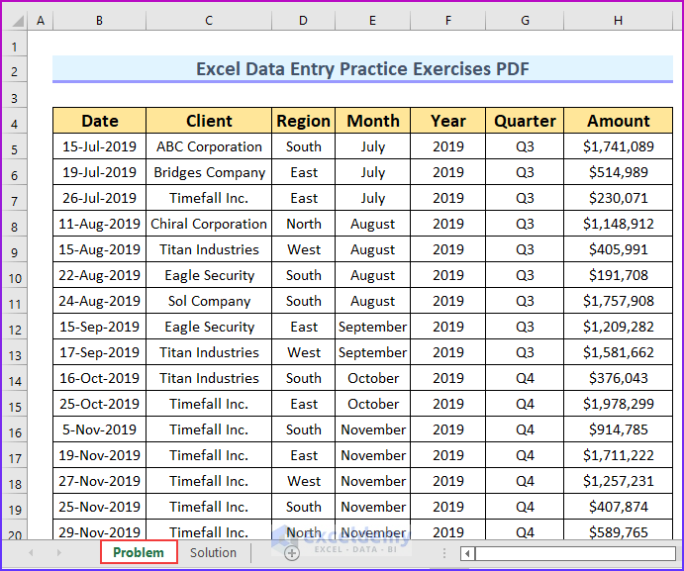

Now, using this data, you will have exercises to solve.

**AD**

* **Question(1):- Inserting Pivot Table:** Your task is to bring up the pivot table. Then [**remove the grand total**](https://www.exceldemy.com/remove-grand-total-from-pivot-table/) and [**edit the pivot table**](https://www.exceldemy.com/edit-a-pivot-table/). Additionally, you can [**hide the Gridlines**](https://www.exceldemy.com/remove-gridlines-in-excel-pivot-table/) from the table.
* The following animated image shows how to hide the grand total value.



**AD**

* **Question (2) :- Grouping Data by Year:** The second task is to group the sales amount by the year. Additionally, you can try to group the data by [**weeks and months**](https://www.exceldemy.com/excel-pivot-table-group-by-week-and-month/).
* **Question (3) :- Finding Running Total by Date:** Your objective is to [**find the running total by date**](https://www.exceldemy.com/excel-pivot-table-running-total-by-date/) using the data.
* **Question (4) :- Inserting a Pie Chart:** You will create a pie chart from the data in this problem.
* **Question (5) :- Adding Slicers to Pivot Table:** In the fifth problem, you will need to insert a slicer to the pivot table.
* **Question (6) :- Using Calculated Field:** You will need to find the sales tax which is 5% of the total sales using the calculated field. Remember, to import the pivot table as a data model.

The following image shows the first three solutions.

**AD**

